Quality Assurance and Quality Control Procedures Form
Company Name: Click or tap here to enter text.
FINISHED PRODUCT Name: Click or tap here to enter text.
Quality Control Testing
Do you require Certificates of Analysis (COAs) from suppliers of RAW MATERIALS?
☐ Yes ☐ No
Are samples of each RAW MATERIAL sent for independent accredited laboratory testing before use?
☐ Yes ☐ No
Are samples of the FINAL PRODUCT sent for independent accredited laboratory testing before use?
☐ Yes ☐ No
Does the laboratory provide results which include limits of detection, units, and method of analysis?
☐ Yes ☐ No
Is any internal testing performed?
☐ Yes ☐ No
Testing performed on RAW MATERIALS (check all that apply):
☐ Purity verification (Nutrient Guarantees) - Click or tap here to enter text.
☐ Heavy metals (As, Cd, Cr, Co, Cu, Hg, Mo, Ni, Pb, Se, Zn)
☐ Microbial pathogens (Salmonella, fecal coliforms, etc.)
☐ Moisture
☐ pH
☐ Sieve
☐ Other (specify): Click or tap here to enter text.
What are your pass/fail criteria for RAW MATERIALS?
☐ Must meet label criteria/SDS Click or tap here to enter text.
☐ Heavy metals below CFIA limits (see appendix A)
☐ Microbial pathogens (Salmonella, fecal coliforms, etc.) below CFIA limits (see Appendix B)
☐ Moisture Level Click or tap here to enter text.
☐ pH Click or tap here to enter text.
☐ Other Click or tap here to enter text.
Testing performed on FINISHED PRODUCT (check all that apply):
☐ Purity verification (Nutrient Guarantees) - Click or tap here to enter text.
☐ Heavy metals (As, Cd, Cr, Co, Cu, Hg, Mo, Ni, Pb, Se, Zn)
☐ Microbial pathogens (Salmonella, fecal coliforms, etc.)
☐ Moisture
☐ pH
☐ Sieve
☐ Other (specify): Click or tap here to enter text.
What are your pass/fail criteria for FINISHED PRODUCT?
☐ Must meet label criteria/SDS Click or tap here to enter text.
☐ Heavy metals below CFIA limits (see appendix A)
☐ Microbial pathogens (Salmonella, fecal coliforms, etc.) below CFIA limits (see Appendix B)
☐ Moisture Level Click or tap here to enter text.
☐ pH Click or tap here to enter text.
☐ Other Click or tap here to enter text.
Manufacturing Controls
Who is responsible for plant operation and batch formulation?
(Name/Title) Click or tap here to enter text.
Are batch sheets maintained for each production run?
☐ Yes ☐ No
Are parameters/controls continuously monitored throughout the production process?
☐ Temperature ☐ pH ☐ Mixing speed ☐ Moisture ☐ Pressure
☐ Other: Click or tap here to enter text.
Instruments used for monitoring:
☐ Hard-wired sensors ☐ Portable meters ☐ Manual recording ☐ Other
If a batch does not meet specifications, describe your corrective action process:
☐ Reprocessed ☐ Disposal ☐ Investigated for cause ☒ Other: Click or tap here to enter text.
Other Comments: Click or tap here to enter text.
Finished Product Testing
Is every lot of finished product tested before release? See Appendix C for heavy metals testing requirements.
☐ Yes ☐ No, how often: ☐ Every lot ☐ Quarterly ☐ Annually
☐ Other: Click or tap here to enter text.
Recordkeeping & Documentation
Retention period for QA/QC records: Click or tap here to enter text. years
Where are records stored?
☐ On-site ☐ Cloud-based ☐ Corporate office ☐ Other: Click or tap here to enter text.
Are lot numbers assigned to all product batches and affixed to the label?
☐ Yes ☐ No
Describe the lot numbering format: Click or tap here to enter text.
Non-Conformance
Do you have procedures for investigating non-conforming products?
☐ Yes ☐ No
If yes, describe briefly: Click or tap here to enter text.
Describe your customer complaint resolution process: Click or tap here to enter text.

Signature:
Role: Click or tap here to enter text.
Date: Click or tap here to enter text.
All of the above information is complete and accurate to the best of my knowledge.

Appendix A
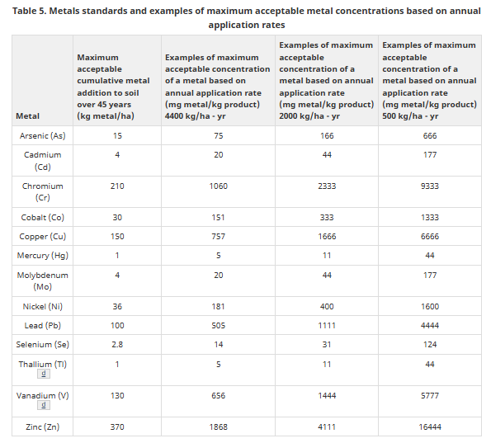
Appendix B
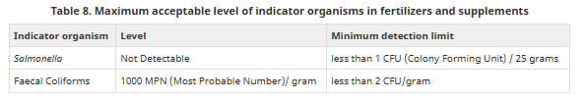
Appendix C
